微算機系統 2025
MICROPROCESSOR SYSTEMS

Lab08 Documentation

Group 34

110590042 柳艾德
112590002 林羿安

Content
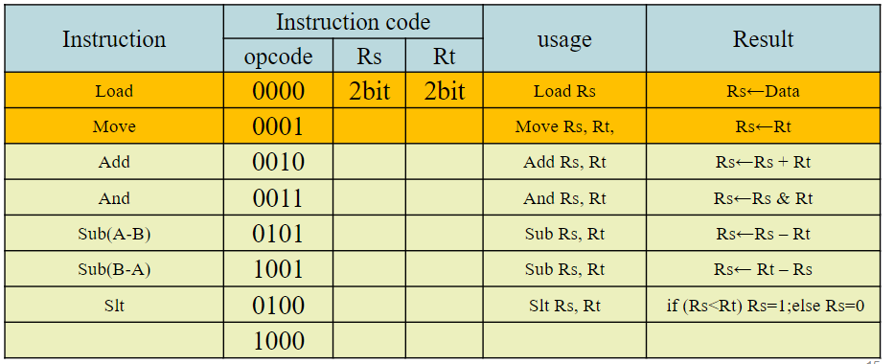
This week’s lab involves creating another finite state machine, to mimic the core functions of a simple CPU. We have 2 registers to store the values for our operations which are determined by the opcode. The opcode sets the state for which operation to be performed and the values of our registers are displayed through our LEDs in hexadecimal.
Process & Results
基於opcode的讀取是clk觸發後馬上處理並顯示結果，因此讓指令狀態為每次loop更新，保證時序上不會出問題，reg_data是使用陣列的方式儲存，所以可以方便的擴充reg的數量與位元數。
[Testing] { 00(Rt), 00(Rs), 0F(Data) }
Data: 00001111(0F), Rs: 00, Opcode: 0000(Load)
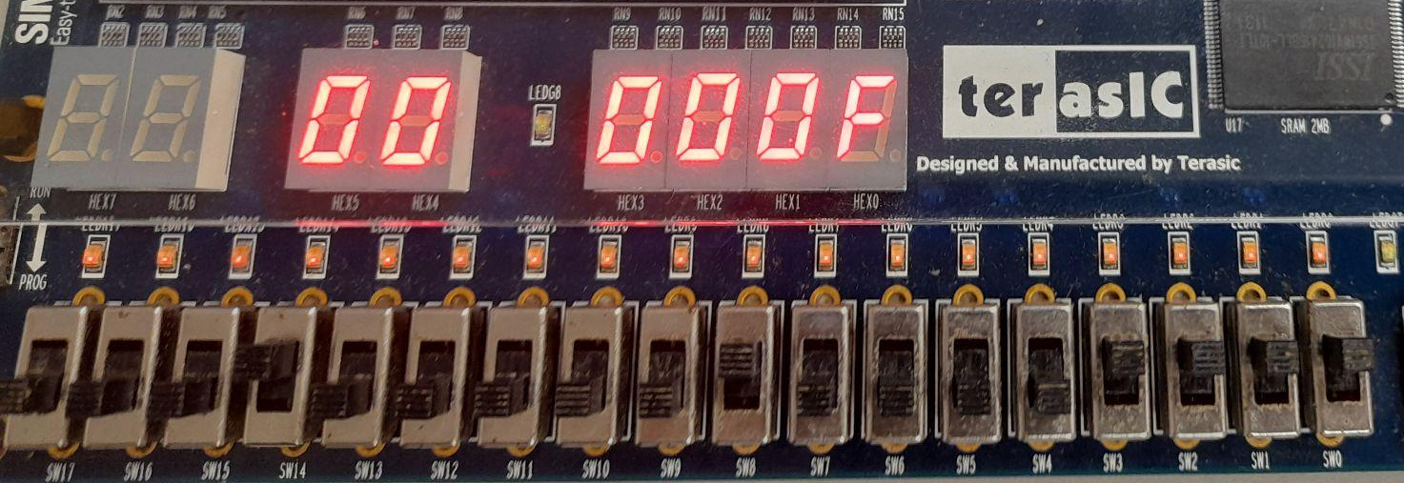
Clk: Rs(value): 00001111(0F)
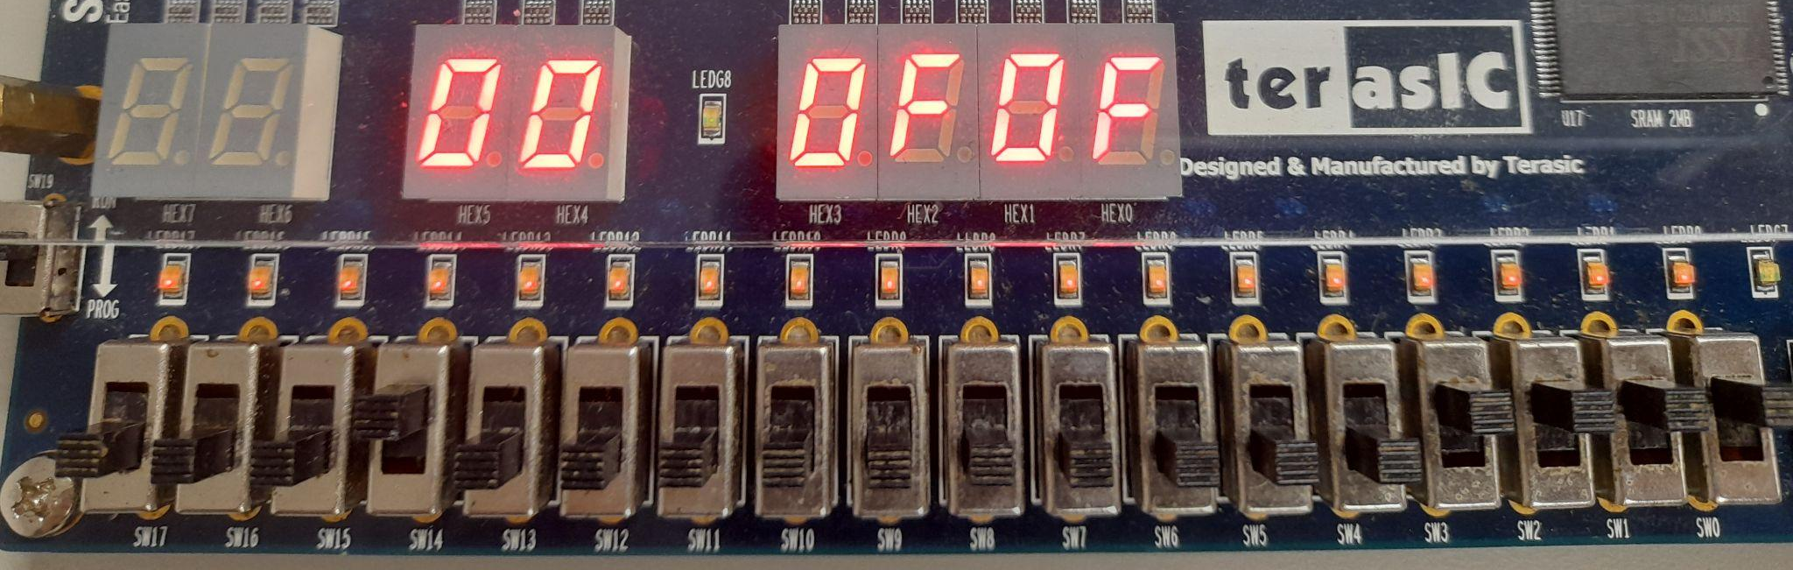

Code

library IEEE;
use IEEE.STD_LOGIC_1164.ALL;
use IEEE.NUMERIC_STD.ALL;
USE work.MyPackage.ALL;
entity SampleCPU is
Port (
-- button input
clk : in STD_LOGIC;
-- switchs input
Opcode : in STD_LOGIC_VECTOR(3 downto 0);
Rs : in STD_LOGIC_VECTOR(1 downto 0);
Rt : in STD_LOGIC_VECTOR(1 downto 0);
Data : in STD_LOGIC_VECTOR(7 downto 0);
-- Hex output
HEX0, HEX1, HEX2, HEX3, HEX4, HEX5 : out STD_LOGIC_VECTOR(6 downto 0)
);
end SampleCPU;
architecture Behavioral of SampleCPU is
type InsStateType is (Load, Move, Add, And1, Sub1, Sub2, Slt, Div);
signal current_ins : InsStateType := Load;
signal bus_data : STD_LOGIC_VECTOR(7 downto 0) := (others => '0');
type reg_array is array (0 to 3) of STD_LOGIC_VECTOR(7 downto 0);
signal r : reg_array := (others => (others => '0')); -- r0 ~ r3
signal rs_seg, rt_seg : STD_LOGIC_VECTOR(7 downto 0) := (others => '0');
begin
process(Opcode)
begin
case Opcode is
when "0000" => current_ins <= Load;
when "0001" => current_ins <= Move;
when "0010" => current_ins <= Add;
when "0011" => current_ins <= And1;
when "0101" => current_ins <= Sub1;
when "1001" => current_ins <= Sub2;
when "0100" => current_ins <= Slt;
when "1000" => current_ins <= Div;
when others => null;
end case;
end process;
process(clk)
variable idx_rs : integer;
variable idx_rt : integer;
variable val_rs : unsigned(7 downto 0);
variable val_rt : unsigned(7 downto 0);
variable result : unsigned(7 downto 0);
begin
if rising_edge(clk) then
-- index conversion
idx_rs := to_integer(unsigned(Rs));
idx_rt := to_integer(unsigned(Rt));
val_rs := unsigned(r(idx_rs));
val_rt := unsigned(r(idx_rt));
case current_ins is
when Load => -- Rs = Data
r(idx_rs) <= bus_data;
when Move => -- Rs = Rt
r(idx_rs) <= r(idx_rt);
when Add => -- Rs = Rs + Rt
result := val_rs + val_rt;
r(idx_rs) <= std_logic_vector(result);
when And1 => -- Rs = Rs AND Rt
r(idx_rs) <= std_logic_vector(val_rs and val_rt);
when Sub1 => -- Rs = Rs - Rt
result := val_rs - val_rt;
r(idx_rs) <= std_logic_vector(result);
when Sub2 => -- Rs = Rt - Rs
result := val_rt - val_rs;
r(idx_rs) <= std_logic_vector(result);
when Slt => -- if (Rs < Rt) Rs = 1; else Rs = 0
if val_rs < val_rt then
r(idx_rs) <= (others => '0');
r(idx_rs)(0) <= '1';
else
r(idx_rs) <= (others => '0');
end if;
when Div => -- Rs = Rs / Rt
if val_rt /= 0 then
result := val_rs / val_rt;
else
result := (others => '0'); -- prevent divide by zero
end if;
r(idx_rs) <= std_logic_vector(result);
when others =>
null;
end case;
end if;
end process;
-- Bus data and read registers to segments
bus_data <= Data;
rs_seg <= r(to_integer(unsigned(Rs)));
rt_seg <= r(to_integer(unsigned(Rt)));
-- 7-segment display instantiation (components assumed pre-declared)
BusHex0: HexDisplay port map(Hex => bus_data(3 downto 0), Seg => HEX0);
BusHex1: HexDisplay port map(Hex => bus_data(7 downto 4), Seg => HEX1);
RsHex0: HexDisplay port map(Hex => rs_seg(3 downto 0), Seg => HEX2);
RsHex1: HexDisplay port map(Hex => rs_seg(7 downto 4), Seg => HEX3);
RtHex0: HexDisplay port map(Hex => rt_seg(3 downto 0), Seg => HEX4);
RtHex1: HexDisplay port map(Hex => rt_seg(7 downto 4), Seg => HEX5);
end Behavioral;

